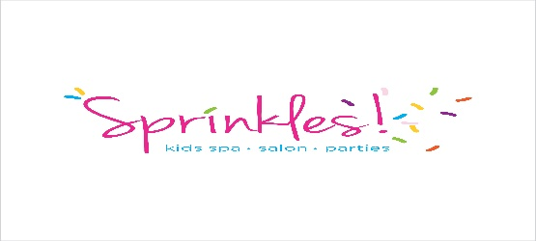
Service:
Stylist:
Child’s Name:
By signing this form, I certify that I am the parent or legal guardian of the child receiving the spa service(s). I acknowledge that I am aware of the health risks inherent in any spa services that my child may receive, and waive any and all claims to damages or injuries that myself or my child may receive, and against Sprinkles Kids Spa, it’s owners and affiliates, employees, and agents for any and all injuries suffered by myself or my child while visiting Sprinkles Kids Spa. I have read this form and understand that by signing this form, I am giving up certain legal rights and/or remedies.
I, ______________________, certify that I am a parent or Legal Guardian of ____________________, who is _____ years of age. I grant permission for my minor child to receive the selected service from Sprinkles Kids Spa under the conditions mentioned above. I understand all services are for entertainment purposes only and therefore, there will be no filing or cutting of the nails.
Does your child have food allergies or allergies to anything that we would need to check our ingredients for? If so, what __________________________________________________________
Signature of Parent or Legal Guardian____________________________
How did you Hear About Us?___________________________________
Email Address ______________________________________________
Today’s Date__________ Cell Number___________________________

